**Personal brand - <Name>**

➼ **Content/Person:**

* Name: ---
* LIST SOME THINGS HERE ABOUT YOURSELF

➼ **Appearance:**

* 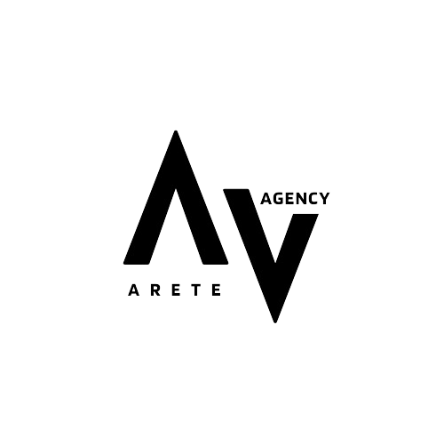Hair Color:
* Body Type:
* Eye color:
* cup size:
* Age:
* Height:
* Location:
* Tattoo number/places:
* Weight:

➼ **Niche:**

* If you were to have a niche before joining us, let us know.
* Otherwise on will be given to you depending on this questionnaire.

➼ **Goal:**

* Show men there’s real love outside
* Make men more confident

↳ Show men that he should love himself as he is and speak kindly to him. X

* Be their online girlfriend
* Assist individuals with their problems.
* Be in a toxic relationship with them and bring them to be emotionally dependent